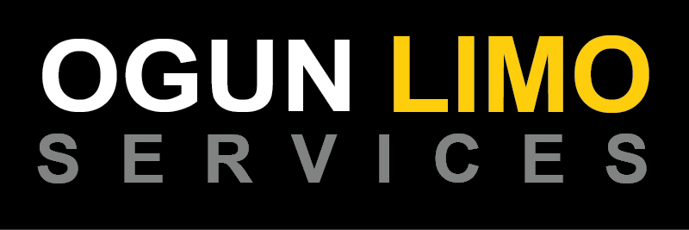
Name
TOLL FREE (877) 416.9696
www.ogunlimo.com

